EXPERIMENT 21 to 23

21.Write a Pandas program to swap the cases of a specified character column
in a given DataFrame.
CODE:
import pandas as pd

# Create a DataFrame
df = pd.DataFrame({
'Name': ['Alice', 'Bob', 'Charlie', 'David'],
'City': ['Chennai', 'Delhi', 'Mumbai', 'Kolkata']
})

print("Original DataFrame:")
print(df)

# Swap the case of the Name column
df['Name'] = df['Name'].str.swapcase()

print("\nDataFrame after swapping case:")
print(df)
OUTPUT:
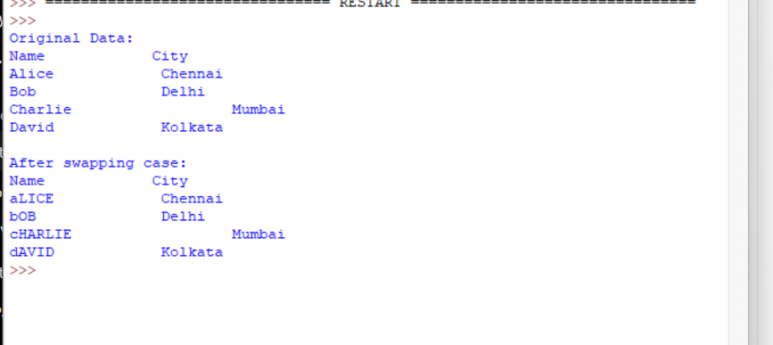
22.Write a Python program to draw a line with suitable label in the x axis, y
axis and a title.
CODE:
import matplotlib.pyplot as plt

# Data
x = [0, 10, 20, 30, 40, 50]
y = [0, 30, 60, 90, 120, 150]

# Draw line
plt.plot(x, y)

# Add labels and title
plt.xlabel("X - axis")
plt.ylabel("Y - axis")
plt.title("Draw a line")

# Display graph
plt.show()
OUTPUT:
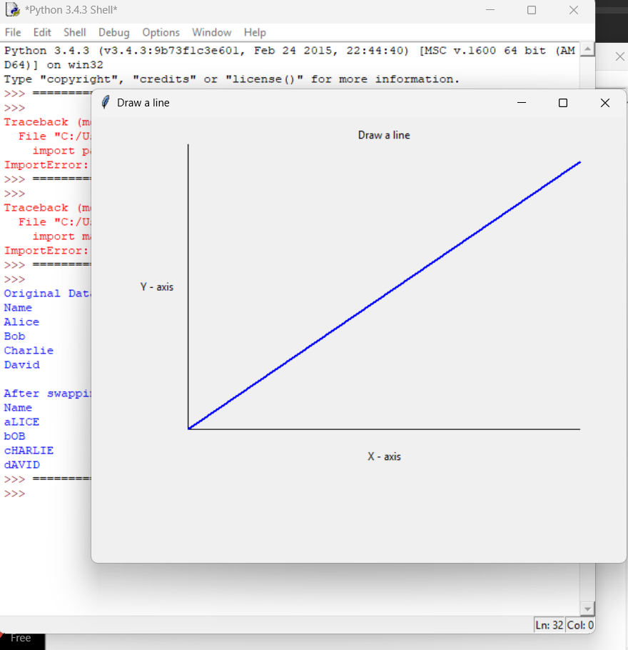
23.Write a Python program to draw a line using given axis values taken from a
text file, with suitable label in the x axis, y axis and a title.
Test Data:
test.txt
1 2
2 4
3 1
CODE:
from tkinter import *

# Create test.txt automatically
file = open("test.txt", "w")
file.write("1 2\n")
file.write("2 4\n")
file.write("3 1\n")
file.close()

# Read values from text file
x = []
y = []

file = open("test.txt", "r")

for line in file:
a, b = line.split()
x.append(int(a))
y.append(int(b))

file.close()

# Create graph window
root = Tk()
root.title("Sample graph")

canvas = Canvas(root, width=600, height=500)
canvas.pack()

# Graph area
left = 80
bottom = 400
right = 550
top = 50

# Draw axes
canvas.create_line(left, bottom, right, bottom)
canvas.create_line(left, bottom, left, top)

# Title and labels
canvas.create_text(315, 25, text="Sample graph!")
canvas.create_text(315, 450, text="X - axis")
canvas.create_text(30, 225, text="Y - axis")

# Draw line using values from file
points = []

for i in range(len(x)):
px = left + (x[i] - 1) * 200
py = bottom - (y[i] - 1) * 100
points.append((px, py))

for i in range(len(points) - 1):
canvas.create_line(
points[i][0], points[i][1],
points[i+1][0], points[i+1][1],
fill="blue",
width=2
)
root.mainloop()
OUTPUT:
